WEEK 5: Mini-ETL Project
Name: Muhammad Awais
MinIO
This screenshot shows that MinIO successfully loaded the CSV file.
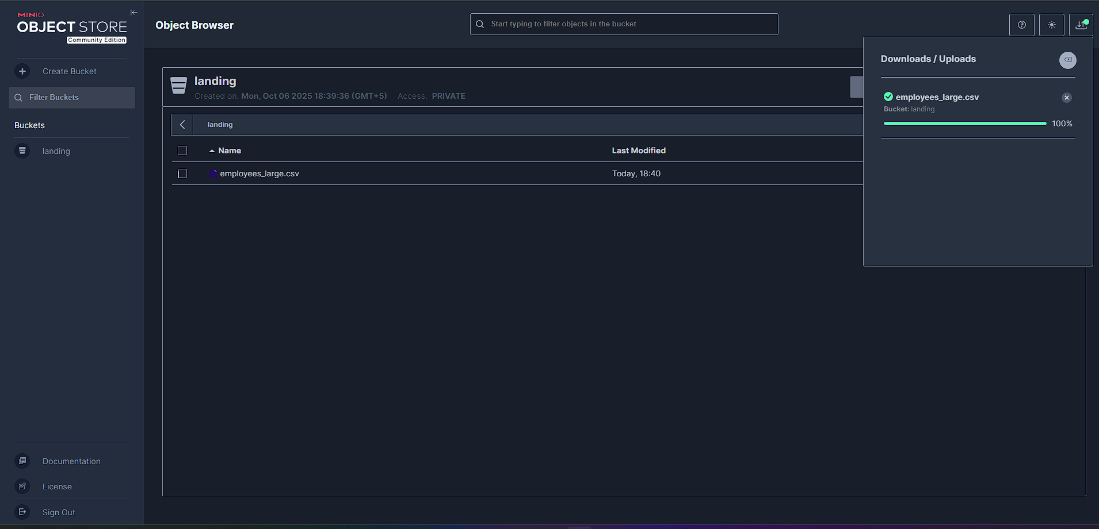
This screenshot shows the ETL script successfully outputting the average employee summary CSV in the processed tab, demonstrating that the CSV file was transformed correctly.
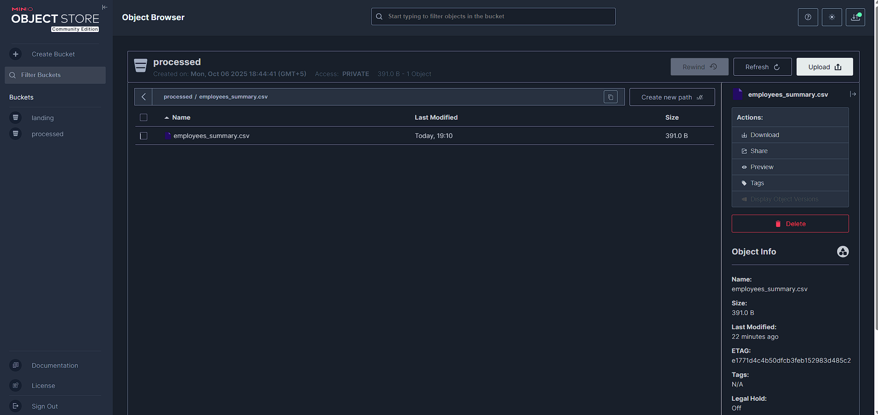
PostgreSQL:
This screenshot verifies that the transformed CSV data was stored in PostgreSQL. We ran a query to fetch the data ordered by employee ID, displaying the top 10 rows.
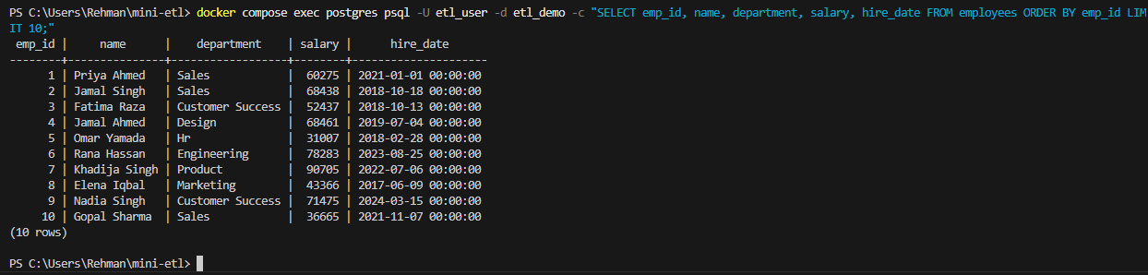
AirFlow
The next screenshot confirms that Airflow ran the ETL DAG successfully, meaning all ETL tasks were executed correctly.
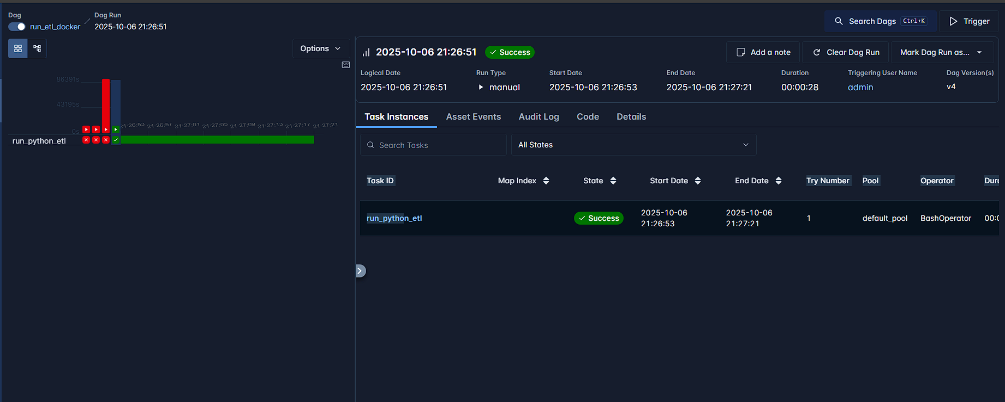

Another screenshot shows the logs, verifying that the ETL code ran properly within the DAG.
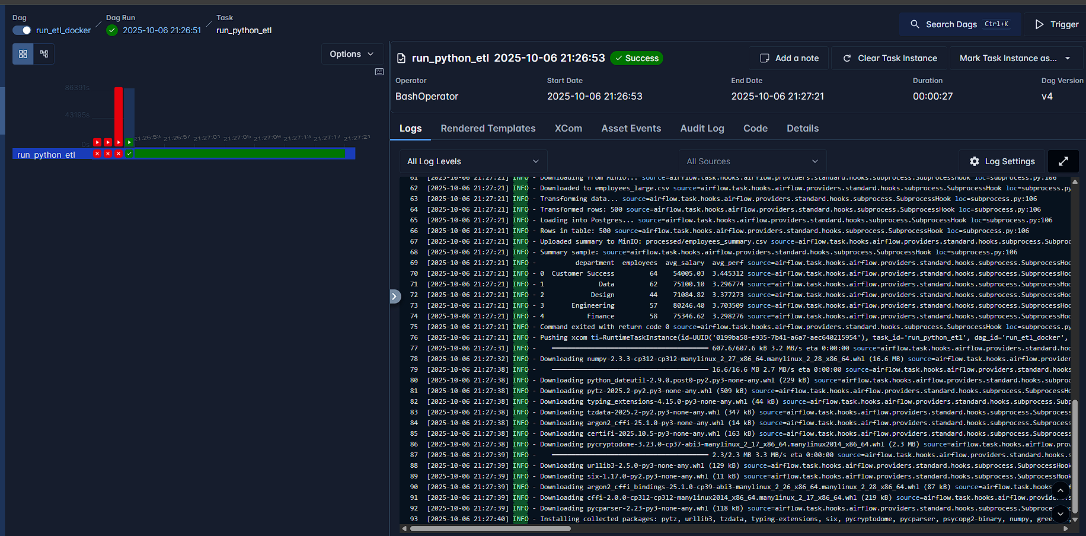
This screenshot confirms that the DAG successfully stored the transformed data in PostgreSQL.
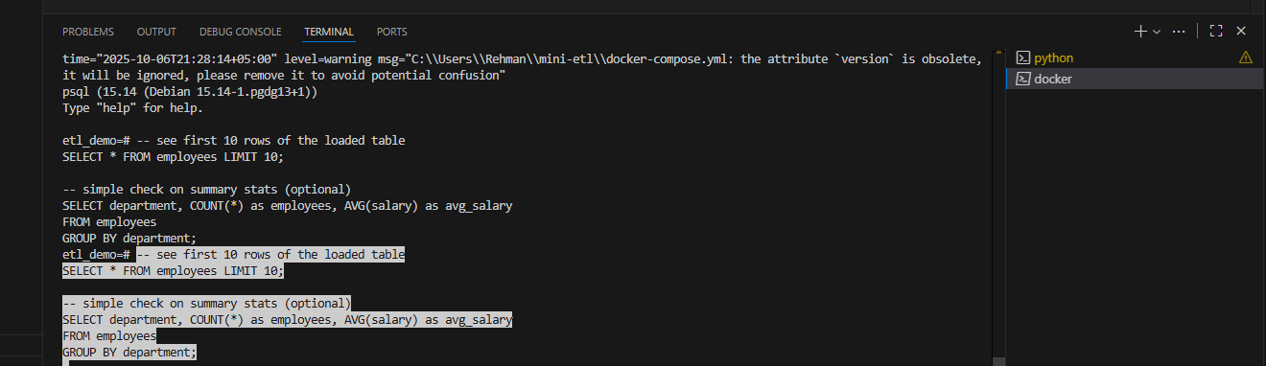
- We can also fetch 10 rows by running a COUNT(*) query limited to 10 results.
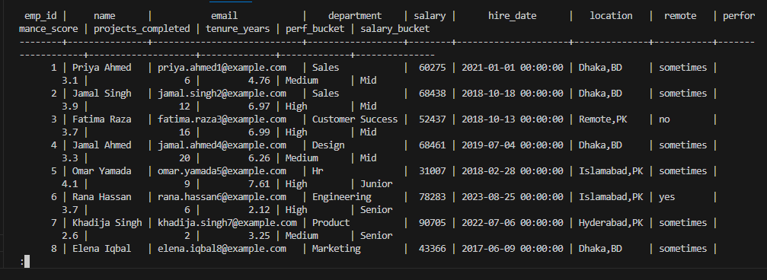
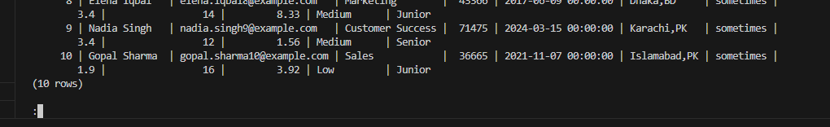
Finally, after the DAG completed, the employees_summary.csv file was updated, showing “Last modified 3 minutes ago,” indicating successful completion of the ETL process.